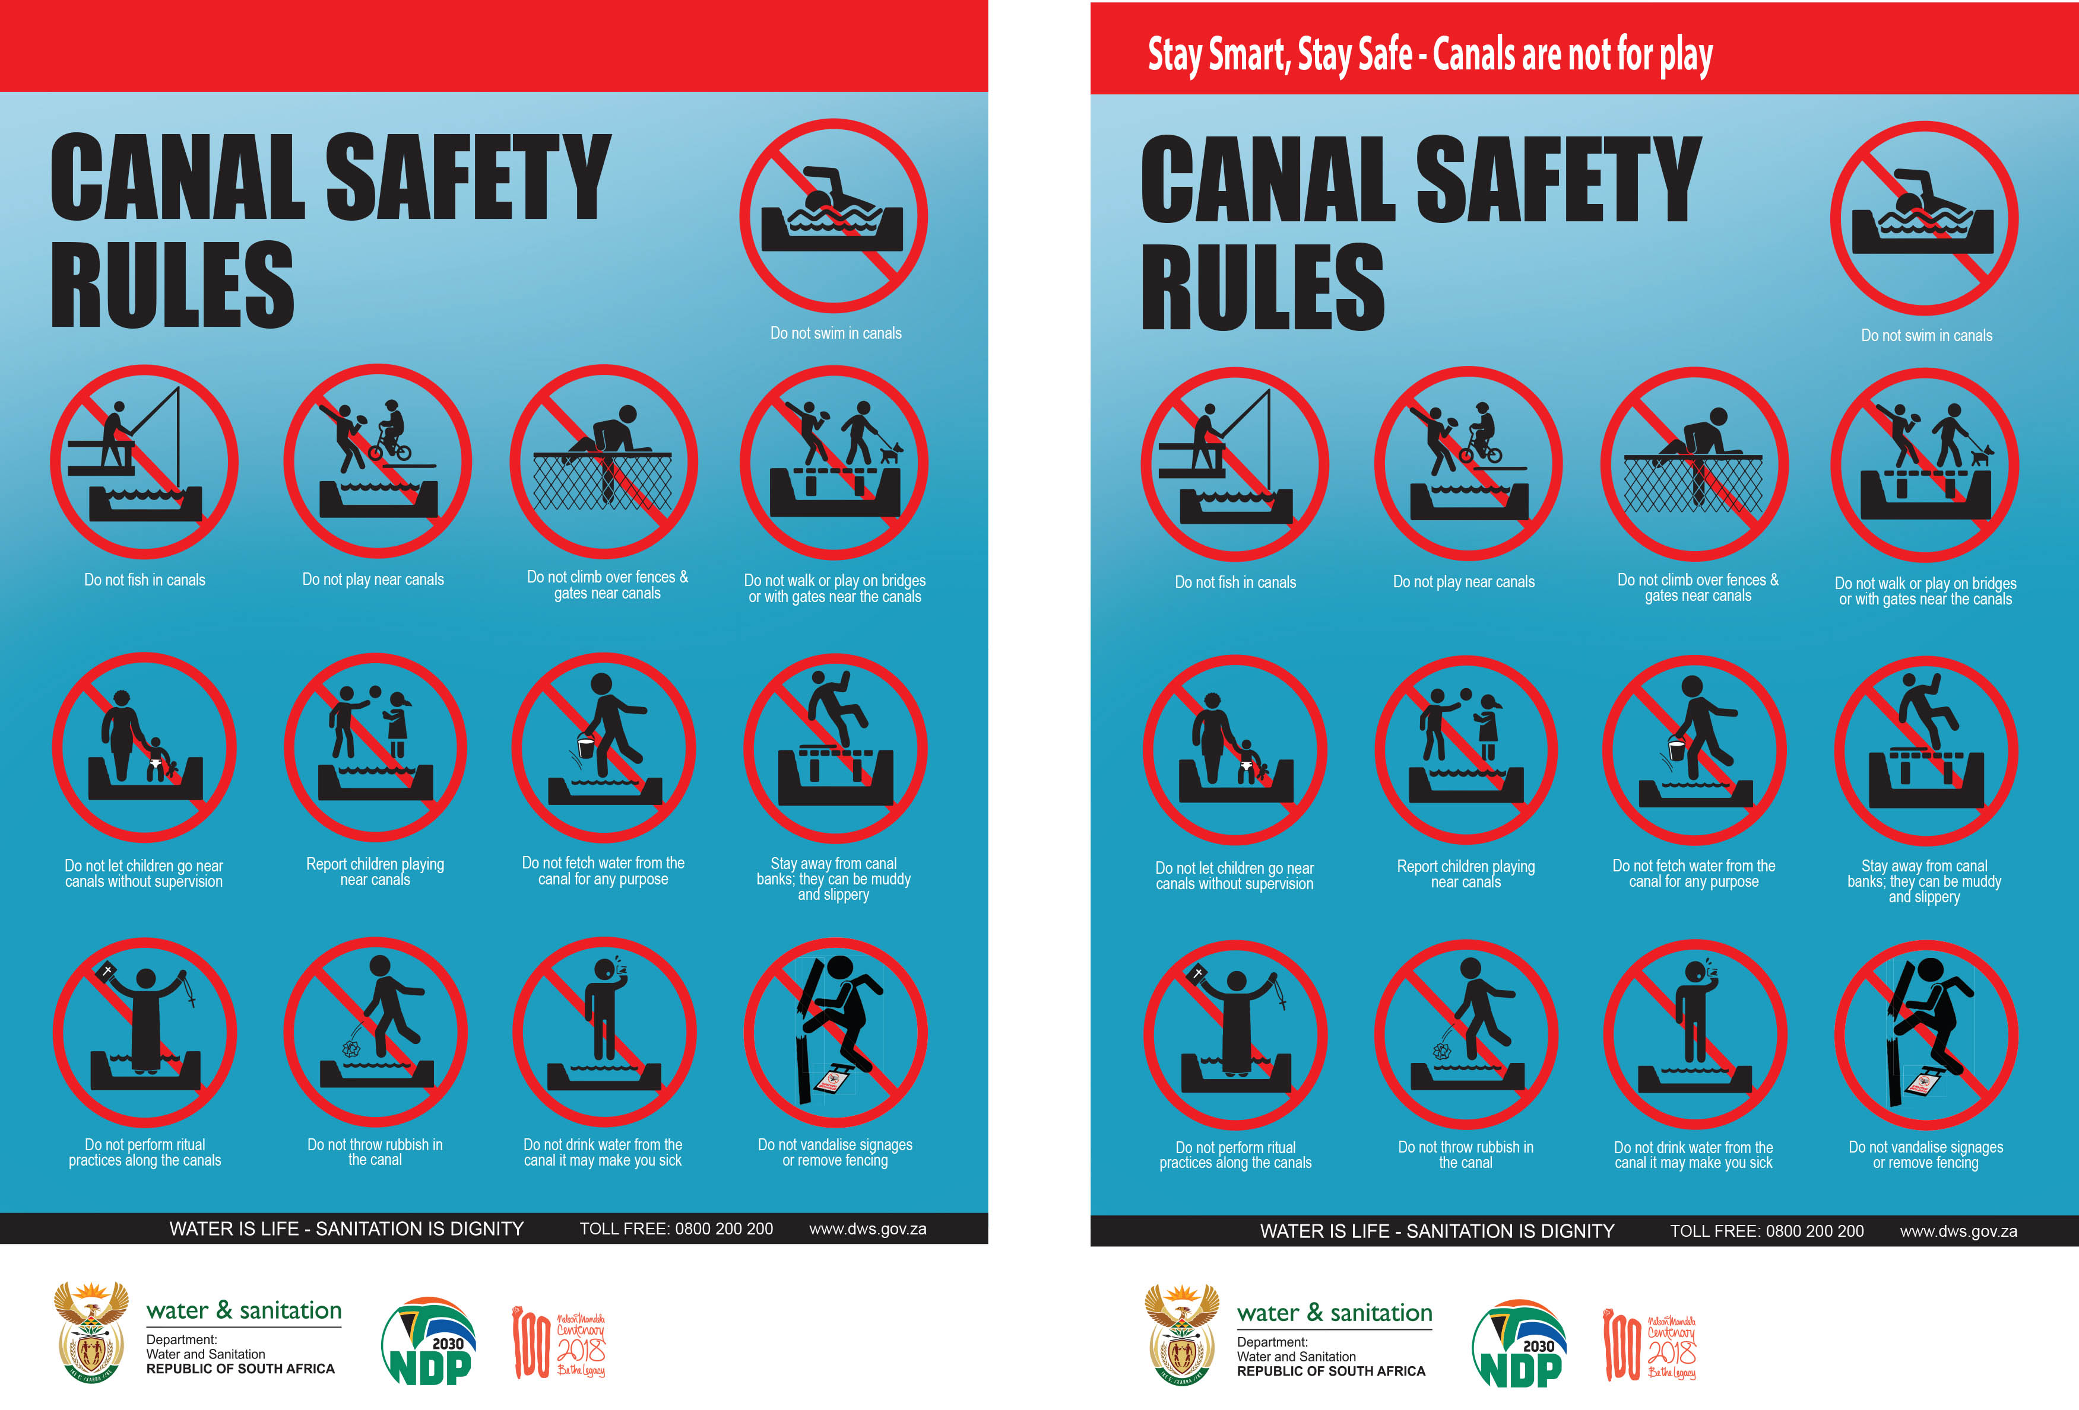

LOGO

LOGO

LOGO

LOGO

LOGO

LOGO

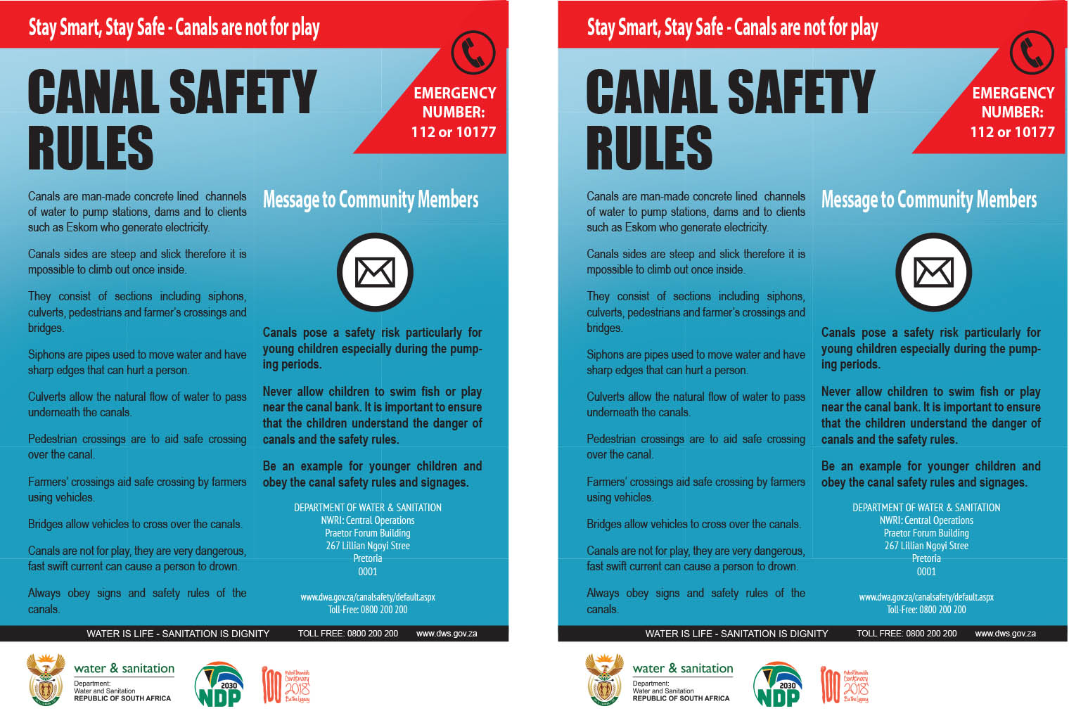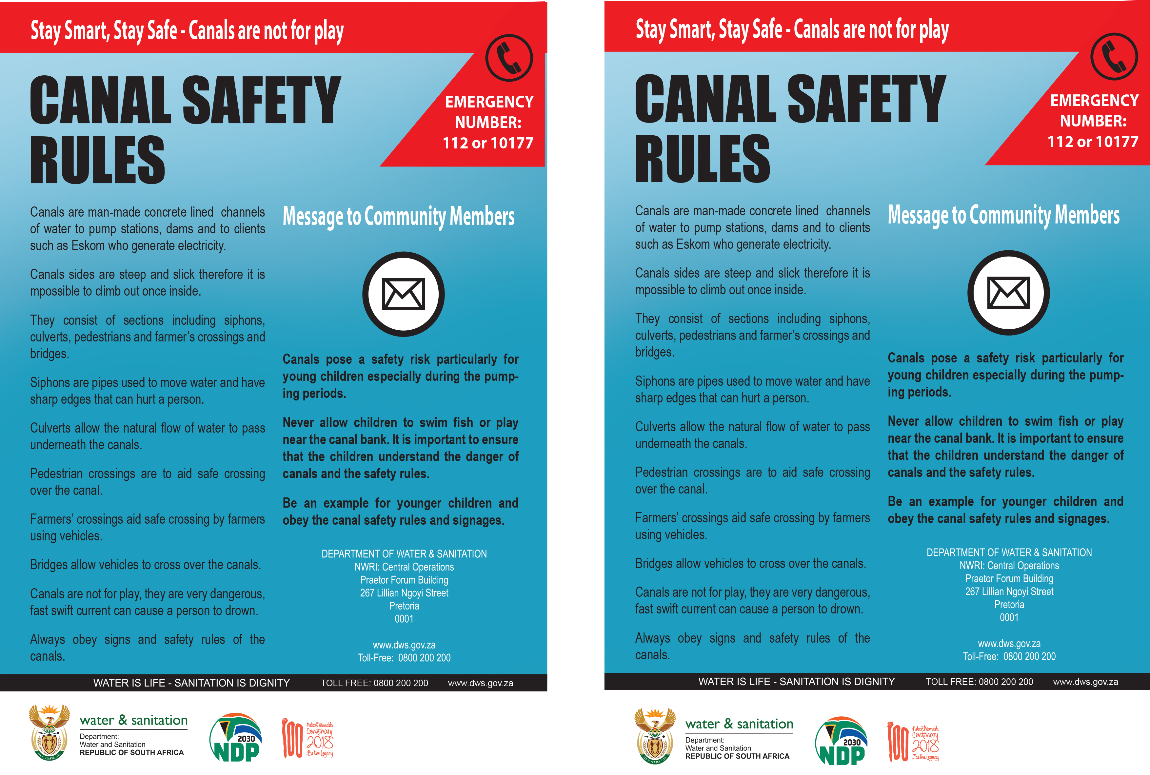

LOGO

LOGO

LOGO

LOGO

LOGO

LOGO

**LOGO**

**LOGO**

**LOGO**

**LOGO**

**LOGO**

**LOGO**